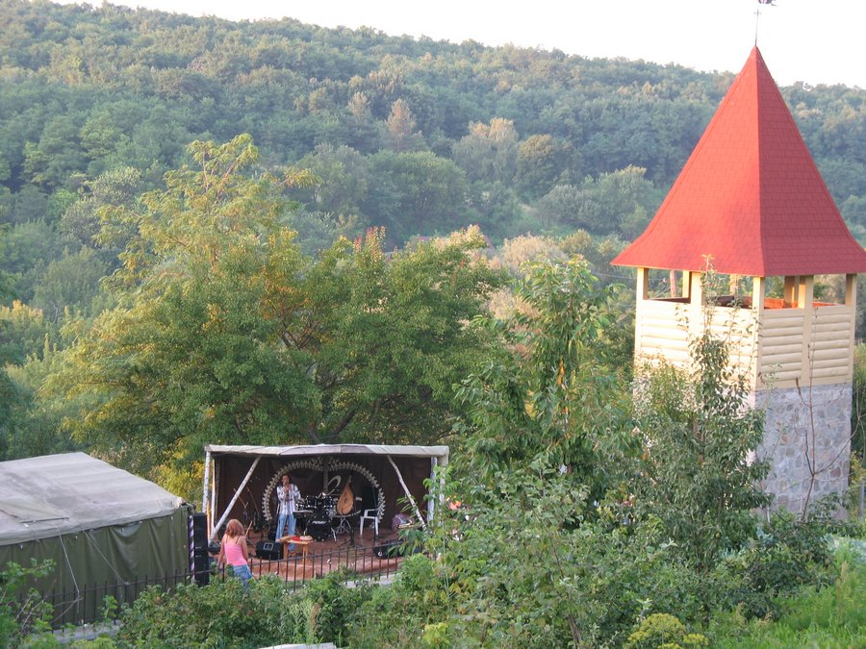
Summer workshops
“Ecological and economical building”

Adobe, air brick, houses from straw and reed, exotic and ecological building in situation of economical and ecological crisis
So old, so forgotten technologies of building... Advanced builder will said: yesterday approaches! Ever we feel ourselves happier in concrete silos? Is it enough of our square meters we have? Are the contemporary technologies meet the challenges of people needs in safe houses?! Look at the window of outmoded urban landscape.
Exactly! All the world today assiduously study and gain proficiency in new and old methods to create the own home keeping harmony with the environment. Here you have possibility to get acknowledged with different kinds of ecological building.

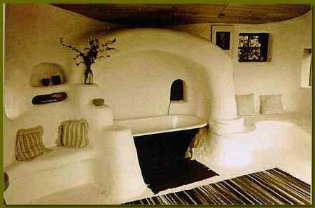
The program includes:
• Kinds of foundations: made ground, stone, columned, wooden, from sacks.
• Materials for walls. Clay usage. Adobe, air brick, cob, timber framing.
• Houses from straw and firewood. Wooden houses, comparison of contemporary and traditional blockhouses.
• Ecological design. Interior decoration, furniture.
• Composting toilet. Septic.
• Roofs: turf, reed, rye straw, tiled, wood chips.
• House heating. Kuznetsov’s stove.
• Building in situation of global crisis. Houses from sacks, tyre casing. Project «kennel».
• Autonomic sources of energy. Solar batteries, wind turbines.
• Known architects and designers.
• Video materials.

Place: Kiev region, village Balyko-Schuchinka, 100 km from Kiev.
Period of time: June, July, August (precise your dates, please!)
The place is easily reachable from the most countries of Europe by its closeness to Kiev. Direct low cost flights by Wizzair are from London, Cologne, Dortmund, Katowice, Oslo and Antalya. No visa is necessary to attend Ukraine for citizens of EU, Switzerland, Canada, USA, Turkey and Japan.
Contact details:
Nataliya Bezborodova,
email: nat_b@ukr.net
phone: +38 050 877 9246
http://www.hatabobriv.org.ua/saman/index.html
Prices:
Description of services | 5 days | 10 days
Accommodation at the seminar site
- seminar sessions  - transfer from/to Kiev  - full-board (no meat)  - living in a tent (bring with you slipping bag and mat) | 250 EUR | 470 EUR
Accommodation in the hotel, 10 km from the site
- seminar sessions  - transfer from/to Kiev  - transfer from/to the site  - full-board (breakfast and dinner – in a hotel, lunch – at the place of seminar)  - hotel accommodation (double and triple rooms available)  - toilet and shower in the hotel, hot water  - air conditioning  - space TV | 370 EUR | 710 EUR
Additional services:
- sauna  - place for barbecue  - horse riding  - massage | 20 EUR per person  5 EUR per person per 6 hours  8 EUR per person per 1 hours  from 5 EUR
Deadline for applications: 3 weeks before your planned date of arrival

